

Resizing Images in GIMP
Version: 0.1
Date: 10 December 2011
Name (ID): Glenn Chamberlain (S3356661)

Internal Use Only

Document History
Date | Author | Description | Version
01/12/11 | Glenn Chamberlain | Initial Design of Assignment 1 | 0.1

About this Document
This document outlines the processes involved in cropping, scaling and altering the quality of a jpeg image in GIMP (an open source image manipulation program). It is assumed that users of this document will have GIMP already installed on their computer system.

Audience
This document is intended for Tibitville Shire technical publications and office staff.

Document Notes:
This document was submitted as assignment 1 for assessment in ‘CPT110: Introduction to Information Technology’ offered through Open Universities Australia (OUA). This document forms 15% of the final mark for the course.

Step 1 – Open the original image in GIMP as shown below then navigating to the applicable directory/media device.
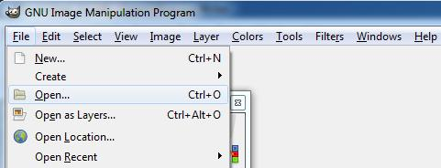

Step 2 – To ensure we don't accidentally make any changes to the original image click File followed by Save As and choose a new location/file name for our working image.

Step 3 – We are now going to crop the opened portrait so that we are left with just a head shot. To select the cropping tool click Tools, hover over Transform Tools and select crop (as shown in below image). Alternatively the keyboard shortcut to select the cropping tool is Shift + C.
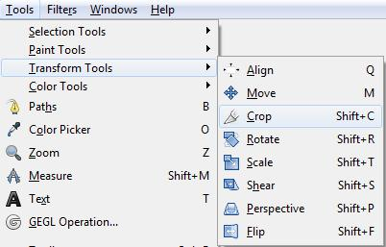

Step 4 – To crop the image you click one corner of the area you wish to include then drag the box to the size you want as shown below.
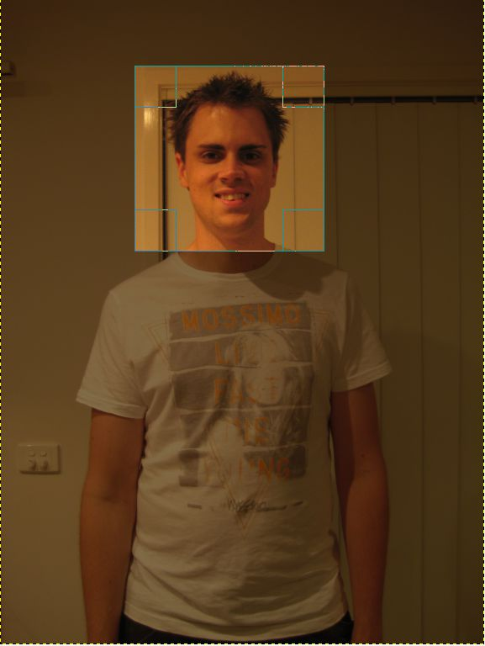

Step 5 – If you need to adjust the size of your cropped box you can do so by clicking and dragging either the sides or corners of your selection.
If you need to move the selection you can click inside the selection and drag to the appropriate place.
If you are happy with your selection press the Enter key and your image will be cropped.
Or alternatively if you wish to start again simply click outside your selection and begin the process again.

Step 6 – We are now going to resize our image into a suitable size for a thumbnail. To adjust the size of the image we need to open the Scale Image tool within GIMP by selecting Image followed by Scale Image as shown below.
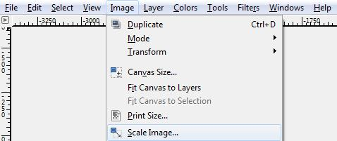

Step 7 – With the Scale Image window open we are now going to reduce our image to the desired thumbnail size. For thumbnails we want the maximum size to be 150 Width x 200 Height. In the image below you will see the Width has been entered as 150 and the height has auto generated as 154, you can play with these numbers in your work to get the desired size but try to stay within the 150x200 boundary.
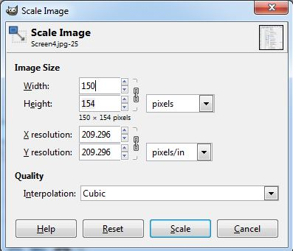

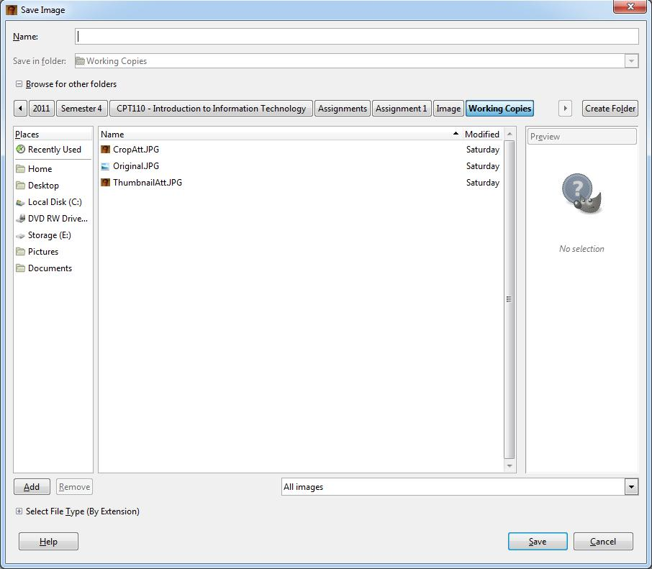
Step 8 – We have now created our thumbnail image. The next step is for us to save our image, and, whilst doing so reduce the file size to an appropriate level. To begin click the File Menu followed by Save As. You will be presented with a screen as shown below. What you need to do is name your file (for example thumb1.jpg – ensure you use have .jpg at the end as this is important for the next step) and choose the destination for the file to be saved too. Once you are happy with your choices click Save.

Note – If you receive an error message saying JPEG file can't handle transparency simply click 'export' (shown below).
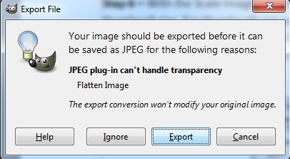

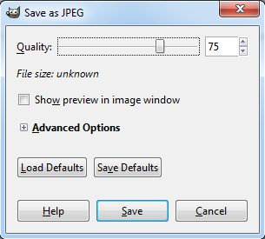
Step 9 – After clicking save you will be presented with a new dialogue box titled 'Save as JPEG'. This is the step where we choose the quality (which directly determines file size) of the image. At this point you may like to tick the check box 'Show preview in image window' – What this will do is allow you to see your image change while you move the quality slider. For the thumbnails I would recommend sticking to around 80 quality but you can play around to see what gives you optimal results.

Advanced Task – Add Border to final Headshot:


Reflective Questions:

1.
The size of the original file was 2.30MB, upon cropping the image the file size was reduced to 305KB.
The file size has reduced after being cropped due to the number of pixels being reduced from 2304 x 3702 to 956 x 848.

2.
The size reduced further again finishing at 28KB for the thumbnail.

3.
Upon applying compression to the thumbnail we were able to reduce the file size further ending at 12KB for the final image. The reason for this final change in size is the reduction of bits available to display the appropriate colours that make up the image.

